Adhavan M G (192421422)
Chapter 4 lab
Program 1: Floyd-Warshall Algorithm (All Pairs Shortest Path)
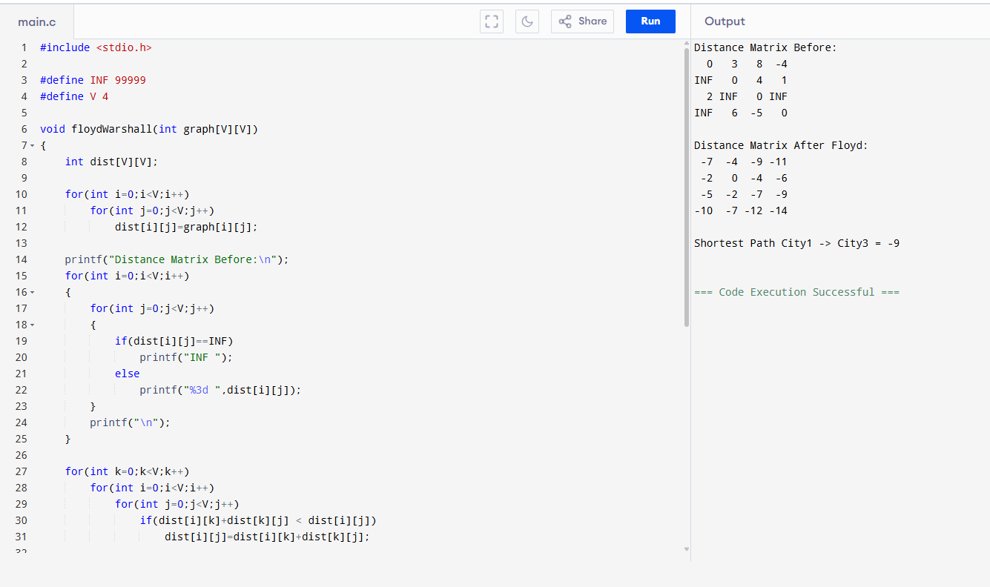

Program 2: Floyd-Warshall with Link Failure
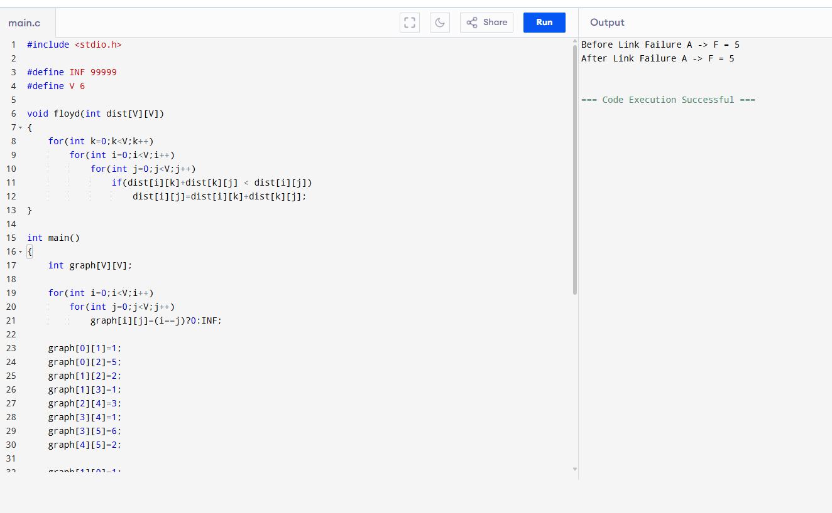

Program 3: Floyd-Warshall City Reachability Problem
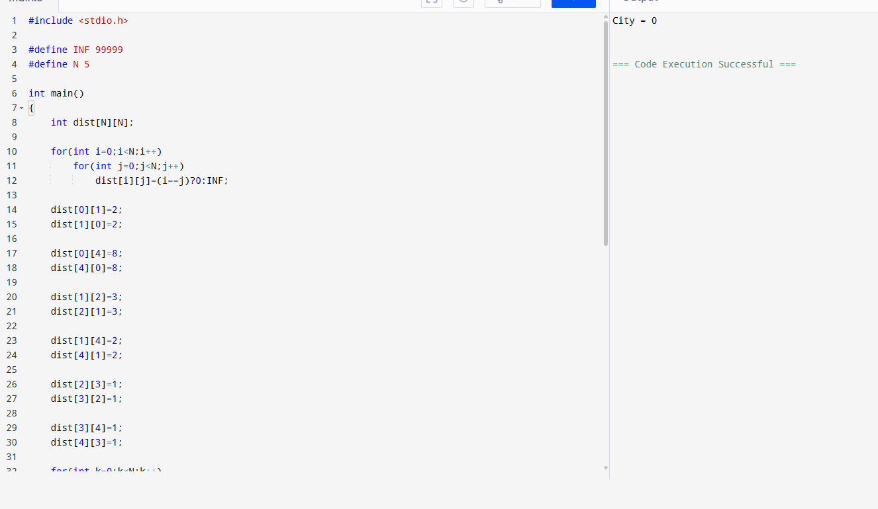
Program 4: Optimal Binary Search Tree (OBST)
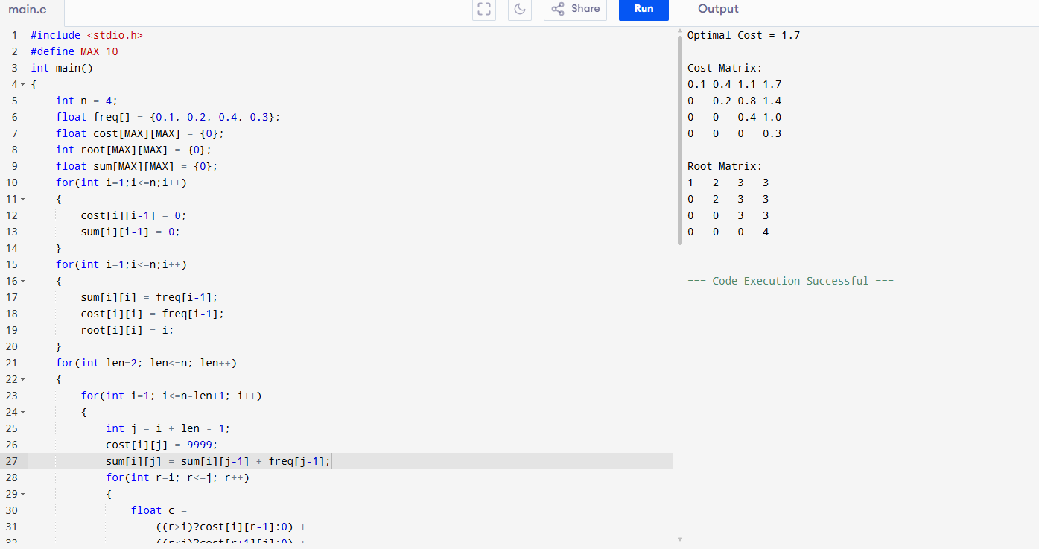

Program 5: OBST for Keys {10,12,16,21}
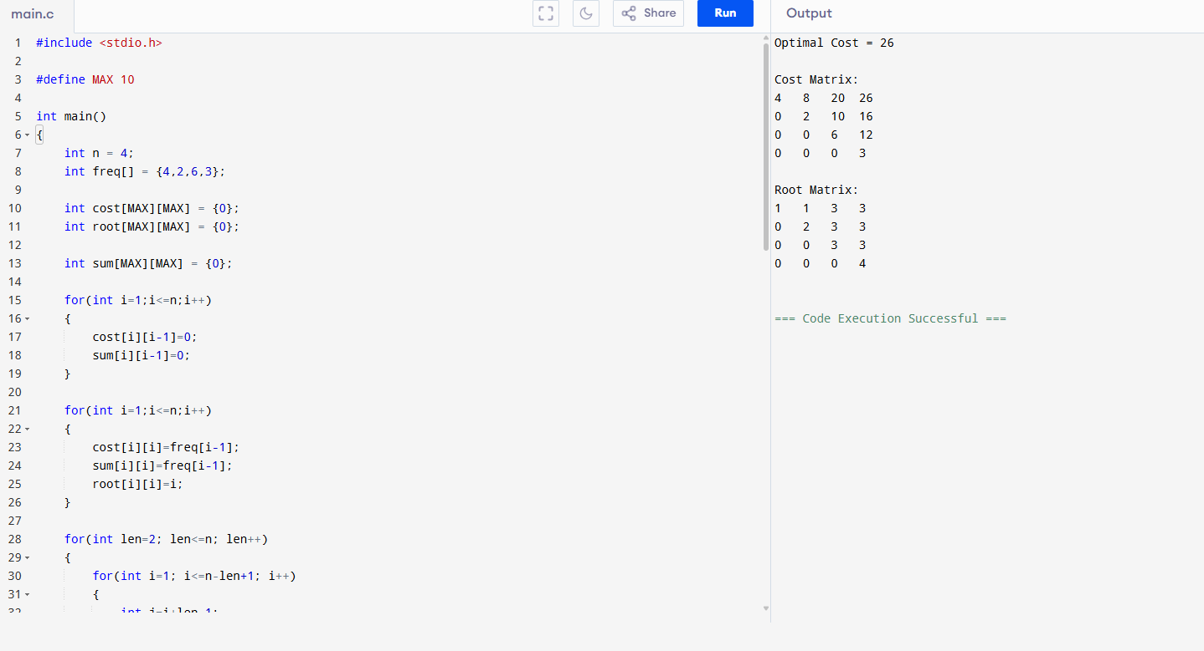
Program 6: Cat and Mouse Game (C Program)
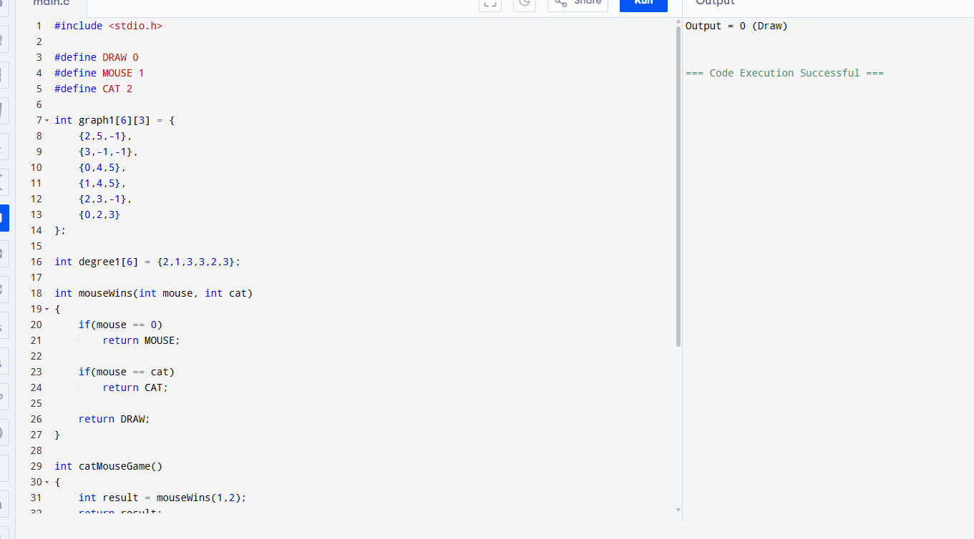

Question 7: Maximum Probability Path (Dijkstra-like)

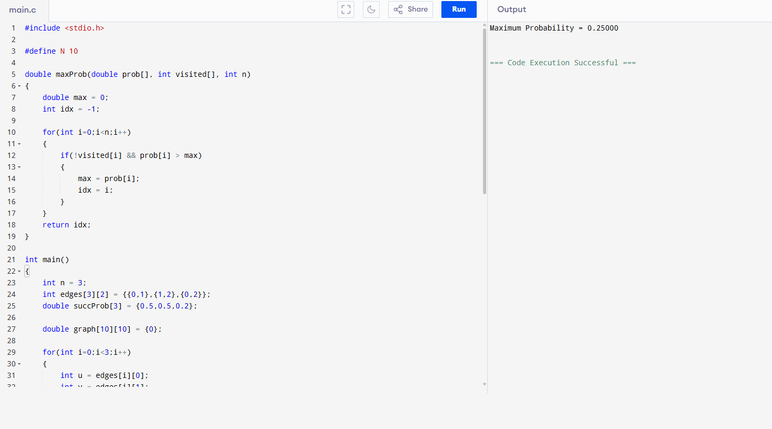

Question 8: Unique Paths (DP)

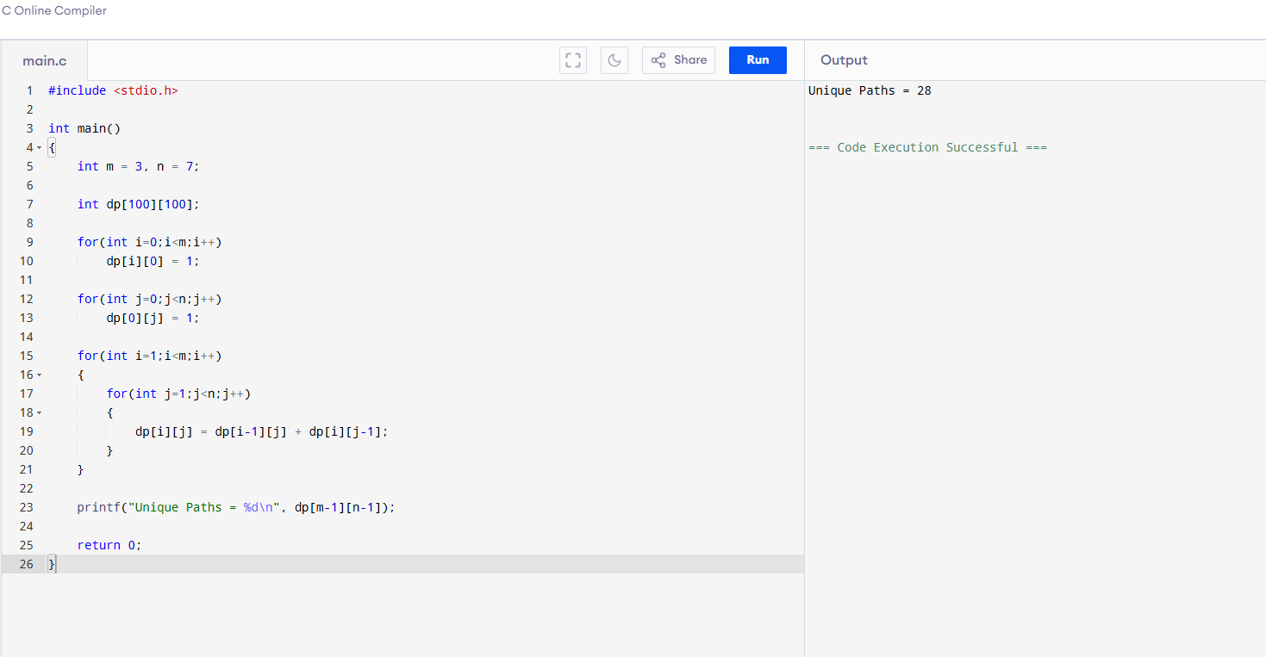

Question 9: Good Pairs

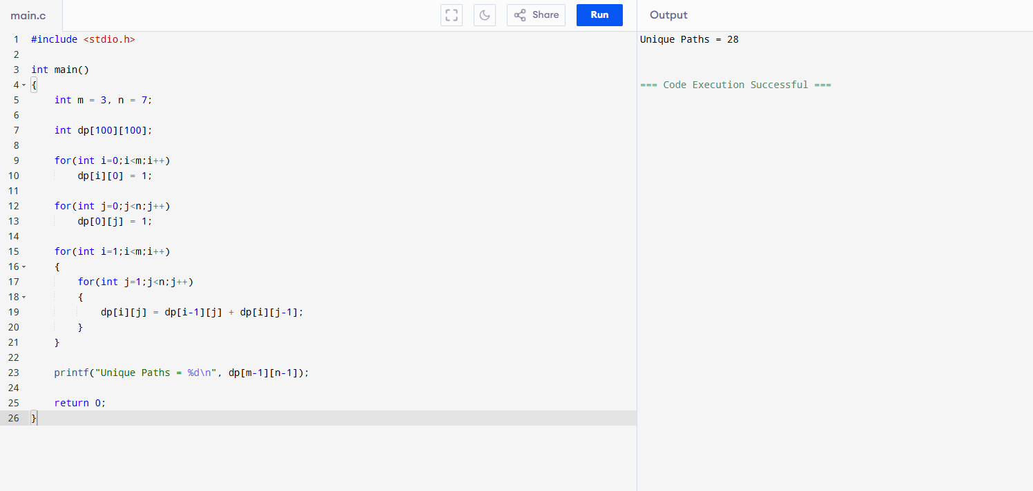

Question 10: 4-Sum Count (A + B + C + D = 0)

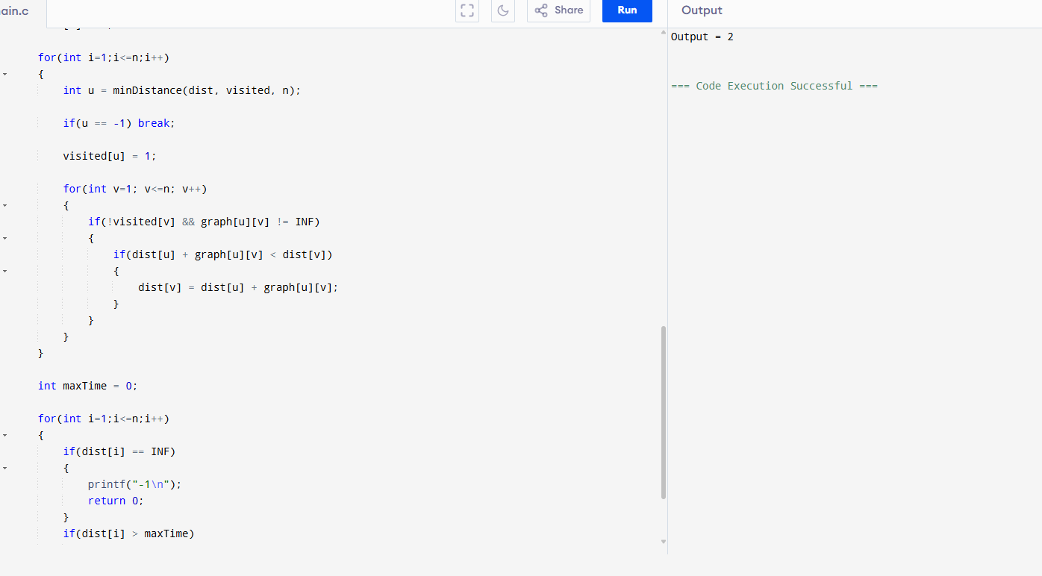

Question 11: Network Delay Time (Dijkstra Algorithm)

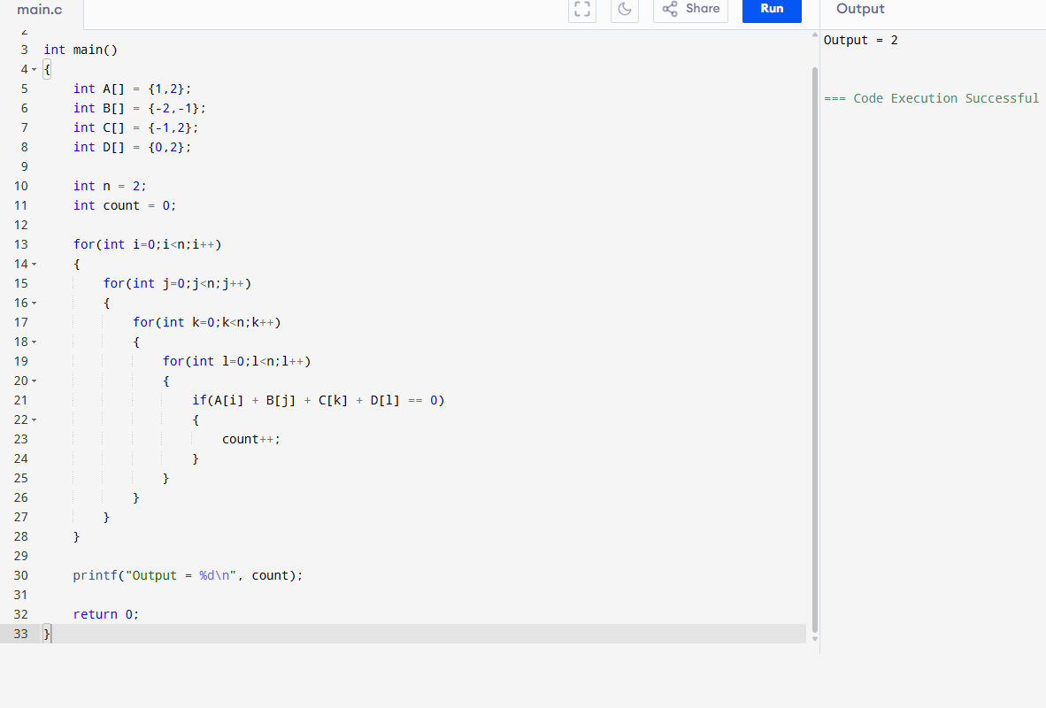

12. Out of Boundary Paths (DP)

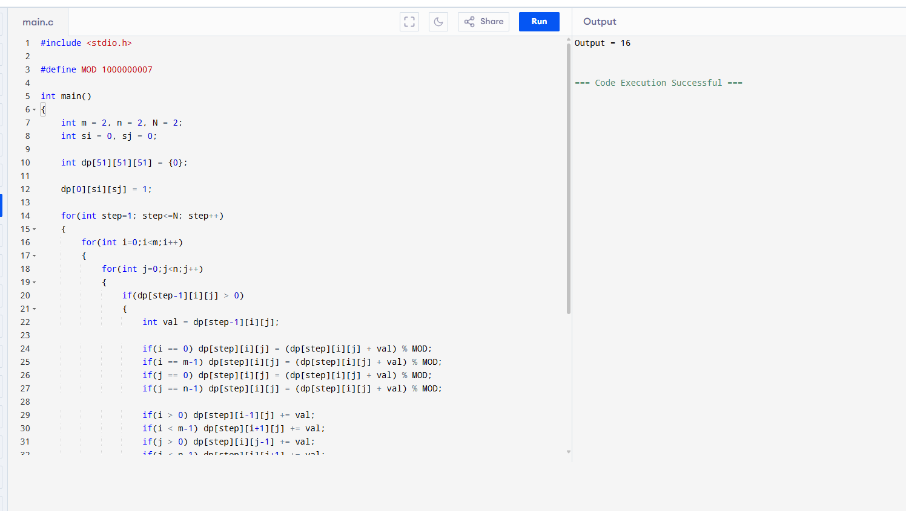

13. House Robber II (Circle)
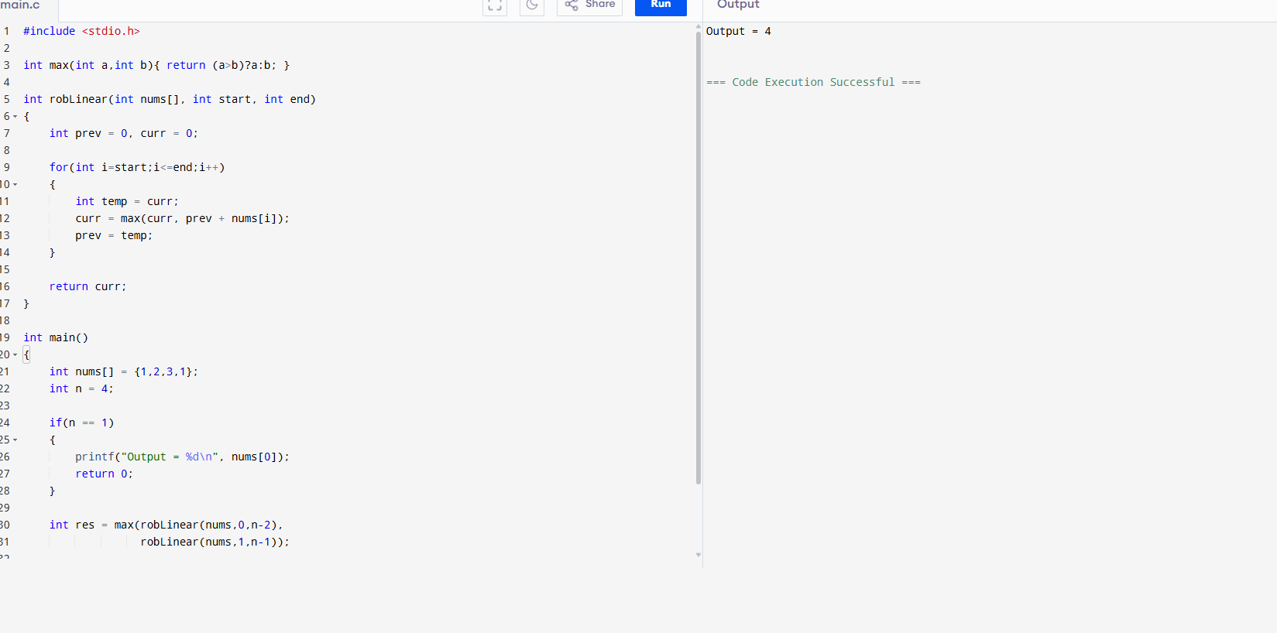
14. Climbing Stairs
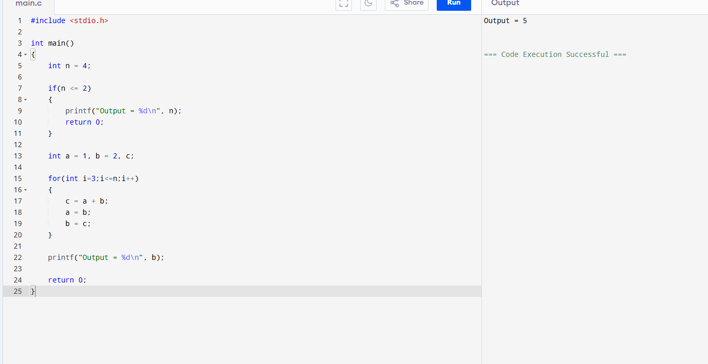

15. Unique Paths (Grid Robot)
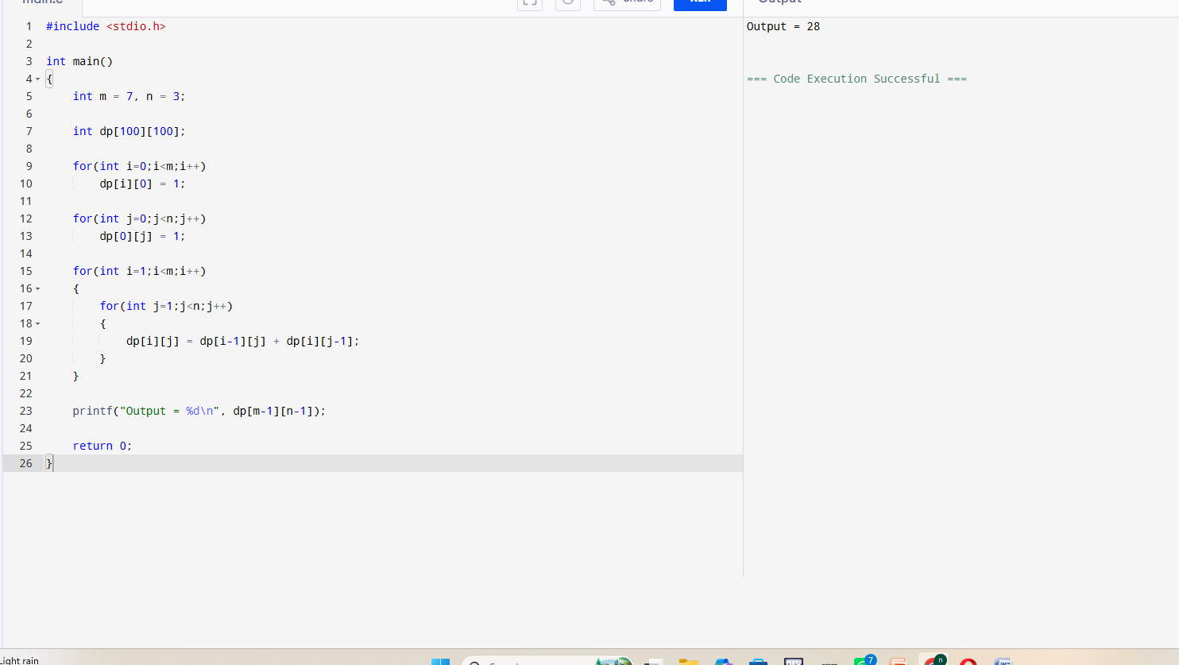
16. Large Groups in String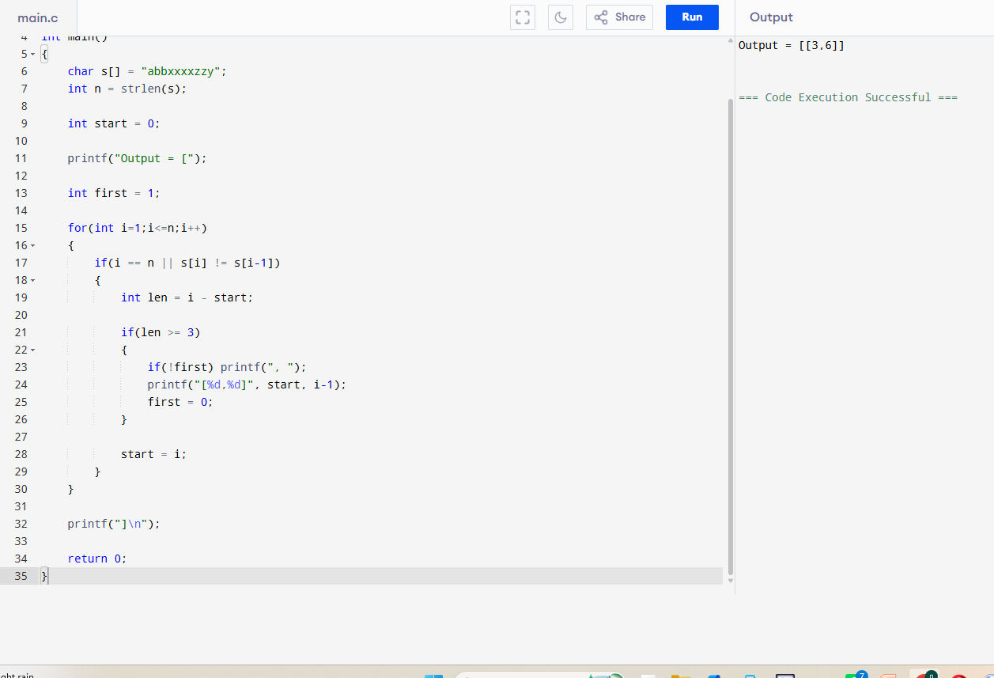

17. Game of Life
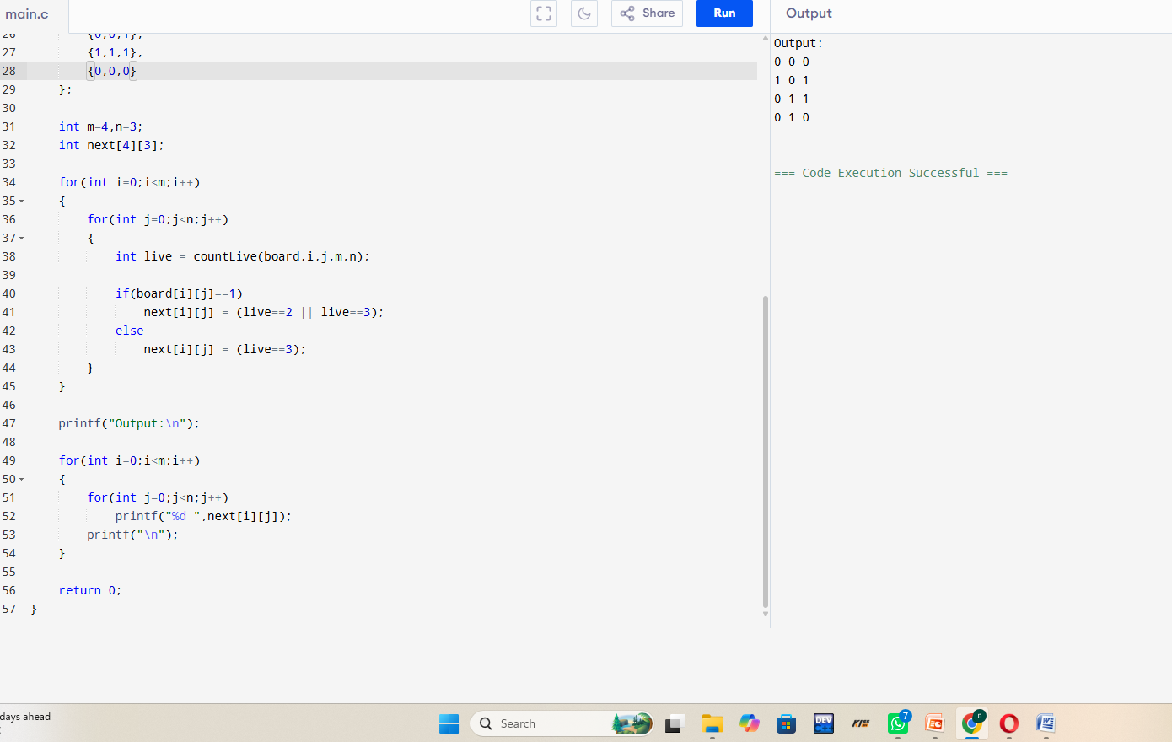
18. Champagne Tower
